The Website Plan: Rafting Company

**Logo**

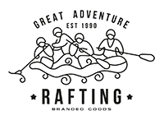

**Color labels:**

1. primary-color = #1E4C7A
2. secondary-color= #FEDC56
3. accent1-color = #E7DB9C
4. accent2-color=#FDF0D5

**Font labels:**

1. heading-font = Bebas Neue
2. text-font = Playfair display

**URL link of the color palette**

<https://coolors.co/1e4c7a-fedc56-e7db9c-fdf0d5>